Red and/or
black dot entries:

ASN LOGO

HISTORIC Technical passport – Valid in: & &

This Technical Passport is not a certificate of authenticity, nor does it in any way verify the history of the car or its constituent parts.
The FIA merely certifies that the required information gathered and confirmed by the ASN at the date of the inspection, is sufficient for the car to be eligible to compete in FIA-sanctioned competitions for historic vehicles.
Neither the FIA nor the ASN certifies or takes responsibility for the accuracy of the items shown below as "represented" as those were provided by the Applicant (as detailed in Page 24), on behalf of the owner, based upon his best available knowledge and are not verifiable by the ASN and/or the FIA.

Issuing ASN: | Form Number: |  | Category:
Period: - to |  | Valid to 31.12. |  | FIA Class:

The original of this document was filled in by the Applicant and verified by the ASN in accordance with Appendix "K" to the FIA International Sporting Code, for cars taking part in historic competitions. This certified copy of the original form remains the property of the FIA and, if replaced with a new form, must be returned to the issuing ASN which holds the original. During the whole competition the car must conform to all the declarations of this HTP.

Make represented: | Model represented:

Year of specification: | FIA identity No. :
Engine type: | Engine capacity: cm³ corrected: cm³
FIA homologation form number (if applicable): | Number of relevant valid pages of homologation form:

COLOUR PHOTOGRAPH OF THE CAR IN ITS PRESENT FORM
Digital photograph of suitable resolution
9 cm x 13 cm
¾ front view of the right side of the complete car

Each page of this form, as well as the edge of each photograph, must bear the stamp of the issuing ASN

We, the , have checked the information given on this form up to and including page 24 and confirm that to the best of our reasonable knowledge and belief as of today, the car complies with the period specification of the make and model represented.
Date: | Signature and stamp: | Name and status of signatory:

FIA HTP vignette

Page1
Signatory ASN: Form n°:

COLOUR PHOTOGRAPH OF THE CAR IN ITS PRESENT FORM
Digital photograph of suitable resolution
9 cm x 13 cm
¾ rear view of the left side of the complete car

In case of homologated car only: if extensions of the original homologation form are used (in accordance with Appendix K), their numbers must be entered below:

In case of homologated car bodywork may only be altered on Competition Grand Touring Cars (GTS) before Period G and on Competition Touring and GTS cars from Period G onwards according to Appendix J of the period. For the avoidance of any doubt there must be attached to this document evidence of Period Specification of changed bodywork according to Appendix K, over stamped by the issuing ASN as authorisation.

For non-homologated cars and homologated cars with non-standard bodywork, a period picture of the model has to be shown below.

PERIOD IMAGE OF BODYWORK OF ORIGINAL CAR

Homologated cars.
For others also display a picture from period, especially as it can authenticate the car livery.

9 cm x 13 cm

Period image. Event: ……………………………………; date of the event:………………………

IMPORTANT: If this model has no International History, tick this box:
Signatory ASN: Form n°:

1 – CHASSIS, suspension
1.1 cHASSIS FRAME
[a] | Is the car fitted with a chassis to the period specifications? yes no
[b] | Clarification:
[c] | Construction (girder, tubular, monocoque, etc.):
[d] | Materials:

1.2 FRONT SUSPENSION
[a] | Is the suspension as per the period specifications and dimensions? yes no
[b] | Clarification:
[c] | Type of suspension (rigid axle, wishbones, de Dion, etc.):
[d] | Type of springs (coil, leaf, torsion bar, etc.):
[e] | Type of dampers (friction, lever, telescopic, etc.):
[f] | Are the dampers adjustable? yes no
[g] | If yes to [f], state the number of adjusters per damper:
[h] | Material of the dampers: Steel Aluminium
[i1] | Is the geometry of suspension adjustable? yes no
[i2] | Is the height of suspension adjustable? yes no
[j] | If yes to [i1] and/or [i2], specify the method (Uniball joints, different mountings, etc.):  i1:  i2:
[k] | Is it fitted with an anti-roll bar? yes no
[l] | If yes, is this bar adjustable? yes no
[m] | Are sensors fitted? yes no
[n] | If yes, list the sensors:

Signatory ASN: Form n°:

COLOUR PHOTOGRAPH OF THE FRONT SUSPENSION

Digital photograph of suitable resolution
Side view, wheel removed, the braking system and suspension must be clearly visible
In case of drum brakes the drum has to be removed and seen on the picture
9 cm x 13 cm

Taking the two pictures into account, all elements of the suspension assembly must be visible.

COLOUR PHOTOGRAPH OF THE FRONT SUSPENSION

Digital photograph of suitable resolution
behind the braking system in longitudinal axis of the car
9 cm x 13 cm

Signatory ASN: Form n°:

1.3 REAR Suspension
[a] | Are the suspension and dimensions as per the period specifications? yes no
[b] | Clarification:
[c] | Type of suspension (rigid axle, wishbones, de Dion, etc.):
[d] | Type of springs (coil, leaf, torsion bar, etc.):
[e] | Type of dampers (friction, lever, telescopic, etc.):
[f] | Are the dampers adjustable? yes no
[g] | If yes to [f], state the number of adjusters per damper:
[h] | Material of the dampers: Steel Aluminium
[i1] | Is the geometry of suspension adjustable? yes no
[i2] | Is the height of suspension adjustable? yes no
[j] | If yes to [i1] and/or [i2], specify the method (Uniball joints, different mountings, etc.):  i1:  i2:
[k] | Is it fitted with an anti-roll bar? yes no
[l] | If yes, is this bar adjustable? yes no
[m] | Are sensors fitted? yes no
[n] | If yes, list the sensors:

Signatory ASN: Form n°:

COLOUR PHOTOGRAPH OF THE REAR SUSPENSION

Digital photograph of suitable resolution
Side view, wheel removed, the braking system and suspension must be clearly visible
In case of drum brakes the drum has to be removed and seen on the picture

9 cm x 13 cm

Taking the two pictures into account, all elements of the suspension assembly must be visible.

COLOUR PHOTOGRAPH OF THE REAR SUSPENSION

Digital photograph of suitable resolution
behind the braking system in longitudinal axis of the car
9 cm x 13 cm

Signatory ASN: Form n°:

2 – ENGINE
2.1 ENGINE
[a] | Is the engine as per the period specifications for this chassis? yes no
[b] | Clarification:
[c] | Is the position of the engine as per the period specifications? yes no
[d] | Clarification:
[e] | Is the cylinder block cast using the period specification material and dimensions? yes no  Specify material:
[f] | Clarification:
[g] | Is the cylinder head cast using the period specification material and dimensions? yes no  Specify material: Casting number:
[h] | Clarification::
[i] | Make: | Casting number of the block:
[j] | Year of manufacture: | Operating method:
[k] | Number of cylinders: | Configuration (straight, V, etc.):
[l] | Bore: original: mm | Stroke: original: mm
 | actual: mm | actual: mm
[m] | Engine capacity: original: cm³ | actual: cm³
[n] | Number of intake ports: Number of plugs per cylinder:  Number of exhaust ports: Number of valves per cylinder:  Number of transportation port (in case of two stroke engines):  Number of rotors (in case of wankel/rotary engine):
[o] | Are the valve sizes as per the period specification? yes no
[p] | Clarification:
[q] | Are sensors fitted? yes no
[r] | If yes, list the sensors:

Signatory ASN: Form n°:

2.2 IGNITION
[a] | Is the system as per the period specifications? yes no
[b] | Clarification:
[c] | Type (magneto, breaker/coil, etc.):
[d] | If the ignition is electronic, specify the make and principle:
[e] | Are sensors fitted? yes no
[f] | If yes, list the sensors:

2.3 FUEL FEED
[a] | Are the make, type and number of carburettors / injection as per the period specifications? yes no
[b] | Clarification:
[c] | Carburettor: Number: Make: Type: ø of venturi in mm:
[d] | Injection : Make: Type:
[e] | If an air restrictor is fitted, diameter of the restrictor: mm
[f] | If supercharged, is the supercharger as per the period specifications? yes no
[g] | Clarification:
[h] | Supercharger: Make: Type: Number:
[i] | If an air cooler is fitted, is it as per the period specifications? yes no
[j] | Clarification:
[k] | Are sensors fitted? yes no
[l] | If yes, list the sensors:

Signatory ASN: Form n°:

2.4 FUEL SYSTEM
[a] | Is the fuel system as per the period specifications? yes no
[b] | Clarification:
[c] | Type of fuel feed (gravity, mechanical pump, electric pump, etc.):
[d] | Is a fuel cooler fitted yes no
[e] | Is the fuel tank as per the period specification location? yes no  Does it comply with Appendix K? yes no
[f] | Clarification:
[g] | Are sensors fitted? yes no
[h] | If yes, list the sensors:

2.5 Lubrication
[a] | Is the system as per the period specifications? yes no
[b] | Clarification:
[c] | Type (wet sump, dry sump, etc.):
[d] | Is an oil cooler fitted? yes no
[e] | If yes, is the cooler as per the period specifications? yes no
[f] | If no, specify and justify the changes in relation to the period specification:
[g] | Is a main circuit oil filter fitted (pre-war cars only)? yes no
[h] | Are sensors fitted? yes no
[i] | If yes, list the sensors:

Signatory ASN: Form n°:

COLOUR PHOTOGRAPH OF THE ENGINE showing all the engine bay
from the left side

Digital photograph of suitable resolution
9 cm x 13 cm

COLOUR PHOTOGRAPH OF THE ENGINE showing all the engine bay
from the right side

Digital photograph of suitable resolution
9 cm x 13 cm

Signatory ASN: Form n°:

3 – Transmission
3.1 GEARBOX
[a] | Is the gearbox as per the period specifications? yes no
[b] | Clarification:
[c] | Make: Type:
[d] | Number of forward gears: reverse gear: yes no
[e] | Number of teeth (for homologated cars only):  1st gear: 2nd gear: 3rd gear:  4th gear: 5th gear: 6th gear:  Constant: alternatives listed in section 9
[f] | Is an oil cooler fitted? yes no
[g] | If yes, is it as per the period specifications? yes no
[h] | Are sensors fitted? yes no
[i] | If yes, list the sensors:

3.2 FINAL DRIVE
[a] | Driven wheels: Front: Rear:
[b] | Drive method (shaft, chain, etc.):
[c] | Is the final drive ratio as per the period specifications? yes no
[d] | Specify the number of teeth used:
[e] | Specify the other number of teeth available as period specifications: - - - - - - - - - - - - - - - -
[f] | Is the differential a limited slip differential? yes no
[g] | If yes: Make: Model: System:
[h] | Is an oil cooler fitted? yes no
[i] | If yes, is it as per the period specifications? yes no
[j] | Are sensors fitted? yes no
[k] | If yes, list the sensors:
Signatory ASN: Form n°:

4 – BRAKES AND STEERING
4.1 BRAKES
[a] | Is the braking system as per the period specifications? yes no
[b] | Clarification:
[c] | Actuation (cable, rod, hydraulic, etc.): Front: Rear: Other option:
[d] | Is the braking system assisted? yes no Other option:
[e] | Specify the system:
[f] | Make: Front: Rear:
[g] | If drum brakes: Drum diameter Front: mm Rear: mm Other: mm
 | Shoe width Front: mm Rear: mm Other: mm
[h] | If disc brakes: Disc diameter Front : mm Rear: mm
 | Max. disc thickness Front: mm Rear: mm
 | Ventilated disc: Front: yes no Rear: yes no
 | Callipers: Material at front: Number of pistons per front calliper:
 | Material at rear: Number of pistons per rear calliper:
[i] | Are sensors fitted? yes no
[j] | If yes, list the sensors:

4.2 STEERING
[a] | Is the steering as per the period specifications? yes no
[b] | Clarification:
[c] | Type (rack and pinion, worm and roller, etc.):
[d] | Is the steering assisted? yes no
[e] | Specify the system:
[f] | Are sensors fitted? yes no
[g] | If yes, list the sensors:

Signatory ASN: Form n°:

5 – WHEELS
5.1 WHEELS
[a] | Are the wheels as per the period specifications? yes no
[b] | Clarification:
[c] | Are the wheels in multiple parts? yes no
[d] | Are the diameter and the width of the wheels as per the period specification? yes no
[e] | Clarification:
[f] | Type and material (wire, pressed steel, alu alloy, magnesium alloy, etc.):  Front: Rear:
[g] | Diameters / widths of rims at the front (specify the units: inches or millimetres):
 | 1. Diameter: Width: 2. Diameter: Width:
 | 3. Diameter: Width: 4. Diameter: Width:
[h] | Diameters / widths of rims at the rear (specify the units: inches or millimetres):
 | 1. Diameter: Width: 2. Diameter: Width:
 | 3. Diameter: Width: 4. Diameter: Width:
[i] | Are sensors fitted? yes no
[j] | If yes, list the sensors:

6 – BODYWORK, LIGHTING
6.1 BODY
[a] | Is the body to the original specification? yes no
[b] | If no, is the body as per the period specifications? yes no
[c] | Clarification:
[d] | Is all the material of the body as per the period specifications? yes no
[e] | Main material:  If other material used specify material and body parts:
[f] | Type (single-seater, coupé, etc.):
[g] | Number of seats:
[h] | Number of doors:

6.2 AERODYNAMIC DEVICES (cars built after 1965 only)
[a] | Are these devices as per the period specifications? yes no
[b] | Clarification:
[c] | Measurements see extension “Aerodynamic Devices (MeasurementS)”

Signatory ASN: Form n°:

6.3 LIGHTING
[a] | Is the lighting as per the period specifications? yes no
[b] | If no, specify and justify the changes in relation to the period specification:
[c] | Is generator fitted? yes no
[d] | If yes, type: dynamo alternator other, specify and justify:

7 – Dimensions
7.1 Dimensions
[a] | Wheelbase: left: mm right: mm
[b] | Only for homologated cars from Period G2 onwards, body width at centre line of axles:
 | Original front: mm Current front: mm
 | Original rear: mm Current rear: mm
[c] | For all other cases, track (track measured between the centres of the tyre treads):
 | Original front: mm Current front: mm
 | Original rear: mm Current rear: mm
[d] | Minimum weight: kg
[e] | Clarification :

8 – DRAWINGS AND/OR PiCtures

If necessary, drawings and/or pictures of the aerodynamic devices, suspension, etc

9 – ADDITIONAL PIECES OF INFORMATION

If necessary, list of alternatives (gearbox ratios, etc)

Signatory ASN: Form n°:

10 – Extension – MANDATORY PHOTOS

COLOUR PHOTOGRAPH OF THE CAR IN ITS PRESENT FORM
Digital photograph of suitable resolution
9 cm x 13 cm
Front view of the the complete car

COLOUR PHOTOGRAPH OF THE CAR IN ITS PRESENT FORM
Digital photograph of suitable resolution
9 cm x 13 cm
Rear view of the complete car

Signatory ASN: Form n°:

COLOUR PHOTOGRAPH OF THE CAR IN ITS PRESENT FORM
Digital photograph of suitable resolution
9 cm x 13 cm
lateral view of the complete car

COLOUR PHOTOGRAPH OF THE DASHBOARD
Digital photograph of suitable resolution
9 cm x 13 cm

Signatory ASN: Form n°:

COLOUR PHOTOGRAPH OF THE COMPLETE BOOT
Digital photograph of suitable resolution
9 cm x 13 cm

COLOUR PHOTOGRAPH OF THE UNDER FLOOR
Digital photograph of suitable resolution
9 cm x 13 cm

Signatory ASN: Form n°:

COLOUR PHOTOGRAPH OF THE GEAR BOX
Digital photograph of suitable resolution
9 cm x 13 cm

COLOUR PHOTOGRAPH OF THE FINAL DRIVE
Digital photograph of suitable resolution
9 cm x 13 cm

Signatory ASN: Form n°:

11 – DOCUMENTARY REFERENCES

Draw up a list of the technical and descriptive references to the car found in documents (books, periodicals, etc.) contemporary with its construction.

Signatory ASN: Form n°:

12 – Extension – Aerodynamic Devices (MeasurementS)

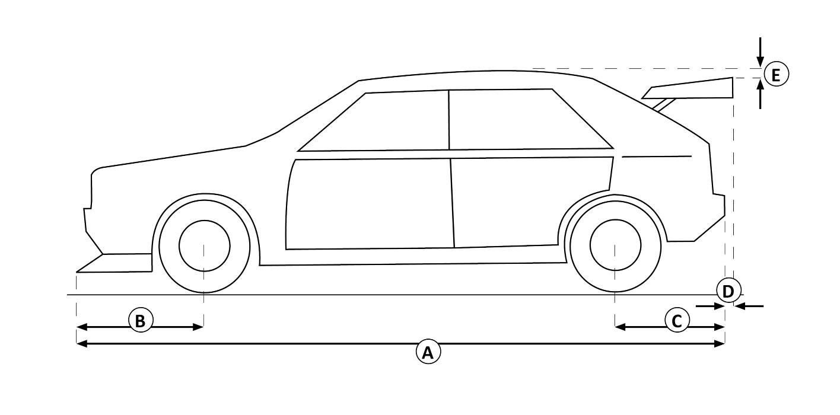

Dimensions (tolerance for all dimensions: +/-1%)
[A] | mm
[B] | mm
[C] | mm
[D] | mm
[E] | mm

Signatory ASN: Form n°:
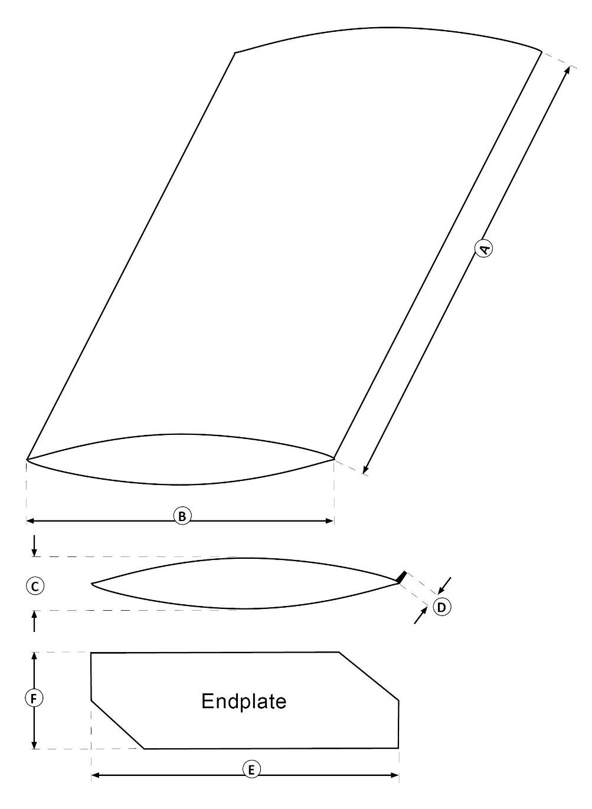
NUMBER OF WINGS:

Dimensions (tolerance for all dimensions: +/-1%)
WING 1 |  | WING 2 |  | WING 3 |  | WING 4
[A] | mm | [A] | mm | [A] | mm | [A] | mm
[B] | mm | [B] | mm | [B] | mm | [B] | mm
[C] | mm | [C] | mm | [C] | mm | [C] | mm
[D] | mm | [D] | mm | [D] | mm | [D] | mm
[E] | mm | [E] | mm | [E] | mm | [E] | mm
[F] | mm | [F] | mm | [F] | mm | [F] | mm

Signatory ASN: Form n°:

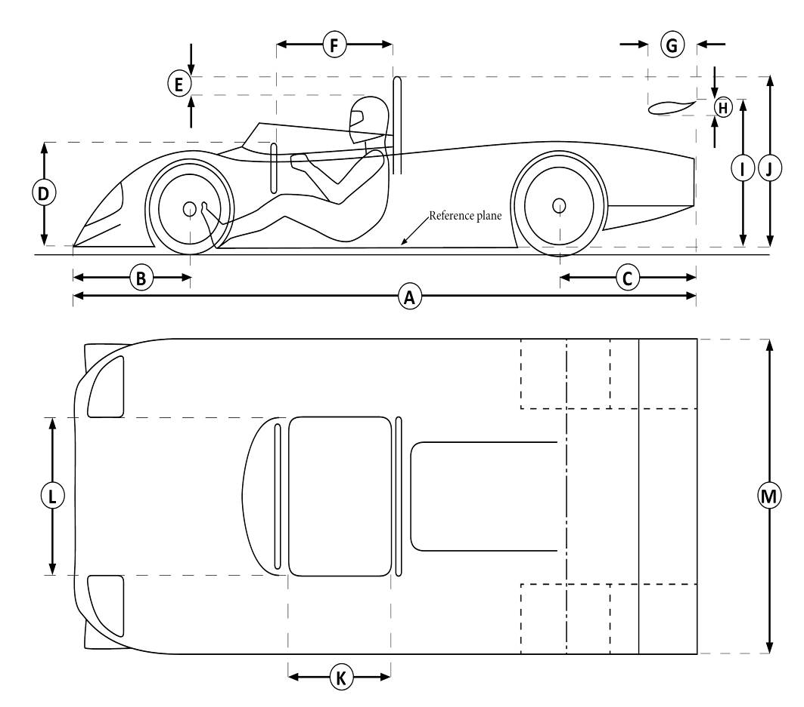Dimensions
(tolerance for all
dimensions: +/-1%)
[A] | mm
[B] | mm
[C] | mm
[D] | mm
[E] | 50 mm min.
[F] | mm
[G] | mm
[H] | mm
[I] | mm
[J] | mm
[K] | mm
[L] | mm
[M] | mm

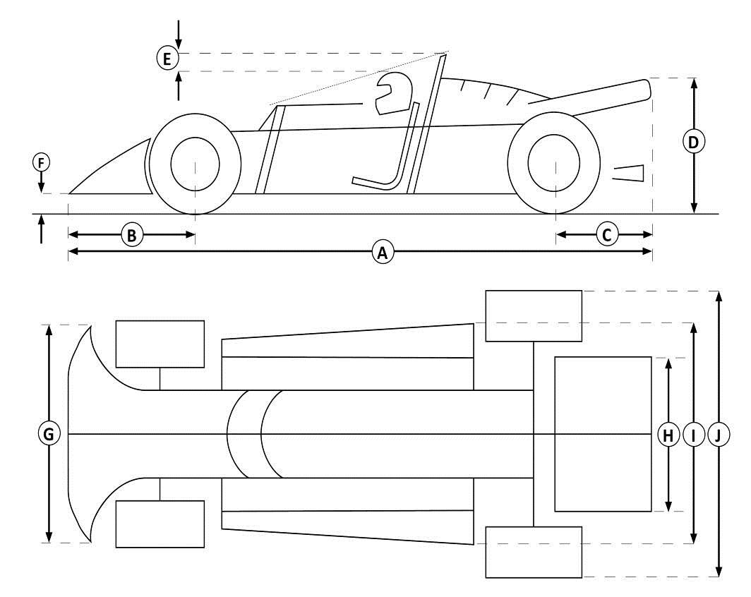

Dimensions
(tolerance for all
dimensions: +/-1%)
[A] | mm
[B] | mm
[C] | mm
[D] | mm max.
[E] | 50 mm min.
[F] | mm min.
[G] | mm
[H] | mm
[I] | mm
[J] | mm

Signatory ASN: Form n°:

13 – Extension – Roll Over Protection system – PART 1

1.1 Roll Over Protection system
[a] | System in accordance with:

1.2 FIA Homologated system
[a] | If on FIA homologation form: Name of manufacturer:
 | Homologation number of the form: Number of the homologation extension:
 | N.B.: A copy of the extension must be attached to the HTP.

1.3 ASN certified system
[a] | If certified by an ASN: Name of the ASN:
 | Certificate / Test report number:
 | N.B.: A copy of the certificate must be attached to the HTP.

1.4 Appendix K system (self made)
[a] | Main/Lateral bar | Front bar | Diagonals | Other struts | Cross braces
Outer diameter (mm)
Wall thickness (mm)

[b] | Material specification:
[c] | Drawing numbers according to App. K - App. VI (including the basic drawings and drawings of all options used):

1.5 Period specification system
[a] | Main/Lateral bar | Front bar | Diagonals | Other struts | Cross braces
Outer diameter (mm)
Wall thickness (mm)

[b] | Material specification:
[c] | Drawing numbers according to App. K - App. VI (including the basic drawings and drawings of all options used):
[d] | Number of mounting points to bodyshell / chassis:

1.6 further information, if necessary:

Signatory ASN: Form n°:
14 – Technical regulations

- The car must comply with the technical regulations for Group of Appendix 19 .
- Or, the car must comply with the following technical regulations: (from 19 ).

The regulations of current Appendix K have priority.

15 – APPLICANT’s Declaration

I as owner or person who has been duly authorised by the owner to submit the application for the HTP, certify (i) that the information given is correct, and (ii) that the authorising ASN will be immediately notified should any changes be made to the car after the present HTP has been issued. I FURTHERMORE acknowledge, that should the car not conform to the specifications set forth herein at any time after issuance of the present HTP, this HTP may be immediately cancelled. I also undertake that any entry form for an FIA international event will be filled in according to the information given on the present form.

Name of the Applicant:
Name of the car owner (if different than the Applicant):
Full address:
Licence number (if applicable):

Date: Signature:

CAUTION: This document is intended solely to verify that, at the date of the inspection, the car appears to be eligible to compete in FIA-sanctioned events for Historic Vehicles (as defined in the International Sporting Code). It makes no representation as to the authenticity or history of the car. The ASN has not inspected the car for any purpose other than that specified above, and neither the ASN nor the FIA shall be held liable, in any way for the accuracy or fitness for a particular purpose (other than the purpose set forth above), of any information contained in this form. Such information has been supplied by the applicant on behalf of the owner of the car, who remains solely responsible for its accuracy.

Change in ownership

Name of the new car owner:
Full address:
Licence number (if applicable):
Name of the new car owner:
Full address:
Licence number (if applicable):
Name of the new car owner:
Full address:
Licence number (if applicable):
Signatory ASN: Form n°:

16 – ELIGIBILITY CHECKS

If the car that is presented for an event is not in conformity with its HTP, refer to article 4.3 of Appendix K.
This table, to be filled in only by FIA event officials and only when necessary, serves to record any comments made subsequent to scrutineering at FIA international events.

Date | Venue | Comments | Name and status of the official

Signatory ASN: Form n°:

17 – LOG Book

This table is not compulsory but may be filled in by Scrutineers (not FIA officials only)

Date | Venue | Comments (e.g. heavy damage after crash or safety errors) | Signature of the official

Form n°:

ONLY FOR SINGLE SEATER CARS, TWO-SEATER RACING CARS AND ANY OTHER CARS EQUIPPED WITH A ROLL OVER PROTECTION SYSTEM (ROPS) WHICH IS NOT HOMOLOGATED OR WHICH IS NOT CERTIFIED BY AN ASN

Tick the box (only one) that applies:
I certify that the ROPS is as per period specification [Section 1.5 of page 23]
I certify that the ROPS is as per Appendix K / self made system in compliance with Article 1.2.5.2 (b) of Appendix VI to Appendix K [Section 1.4 of page 23]

Or

I certify that the ROPS is as per Appendix K / self made system in compliance with Article 1.2.5.2 (a) of Appendix VI to Appendix K and that I have the relevant certificate substantiating the ROPS strength [Section 1.4 of page 23]

As the issuing ASN is unable to control the following technical parameters without affecting the structural, historical and/or patrimonial integrity of the car (analysis of the material impossible without partial destruction or sampling of material), the issuing ASN relies on the Applicant’s representations and the issuing ASN and/or the FIA shall not in any way be held responsible for any incorrect, inaccurate, false or misleading information provided herein by the Applicant.

 | Main/Lateral bar | Front bar | Diagonals | Other struts | Cross braces
Wall thickness (mm)
Material specifications

The items shown above are those claimed by the applicant based upon his best available knowledge.

Applicant First Name:
Applicant Last Name:

Date: Name & Signature:

